Capstone Project 3

Project Title

“Traffic Sign Recognition”

Project Proposed by

Anshul Bhardwaj

Project Mentor

Gritank Dhamija

**Problem Statement**

Automated Traffic Sign recognition is an important part of self-driving vehicles.

Traffic Signs can provide range of variations between classes in terms of colors and shape. In this project, I develop Deep Learning algorithms that will train on German Traffic Signs image dataset and them use these algorithms to classify unlabeled Traffic Signs images. The deep learning models will be built using Convolutional Neural Network and Transfer Learning.

**Data Wrangling & EDA**

The image dataset provided Kaggle contained 39029 train images and 12630 test images.

A total of 43 classes of images were there in dataset. The image dataset had the following distribution

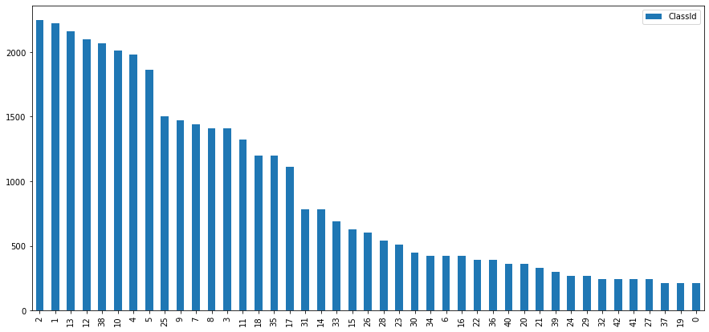

* Class 2 images had the highest value count of 2250.
* Class 0 images had the lowest value count of 210.

**Traffic Sign Meta Images**

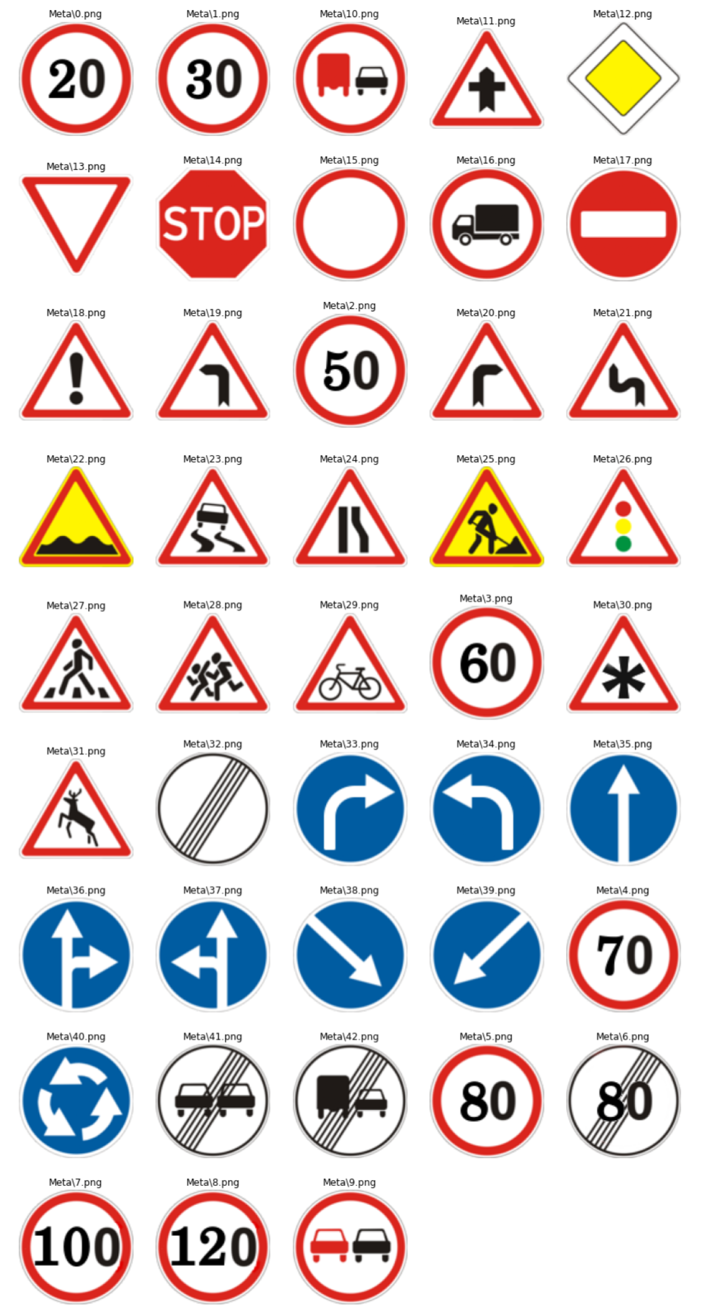

**Augmenting the Images**

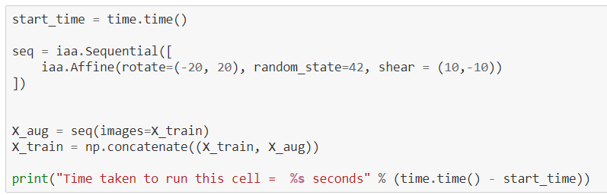

To double the number of images for training, I did Affine transformations on the images.

**Examples of Image Augmentation:**

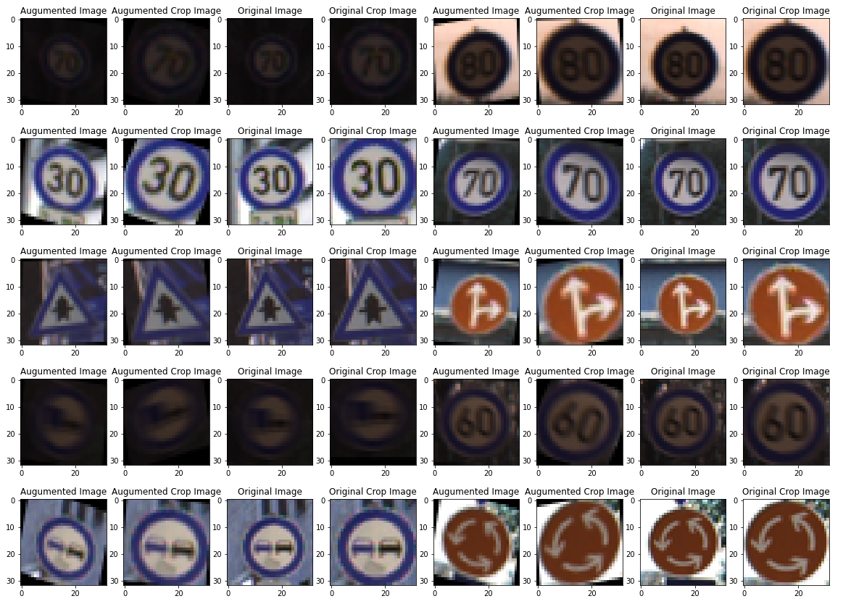

**Image Generators**

To reduce ram uses Image Generators were created using Keras Image generator function.

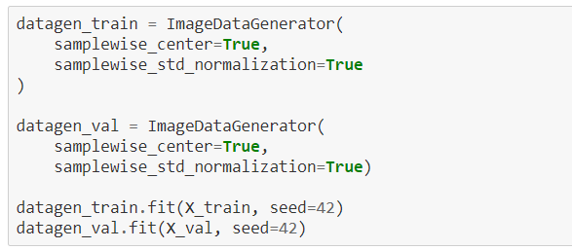

**Model Training**

I created three Deep Learning models. Two of them were made with the help of transfer learning and the remaining was made with the help of Convolution Neural Networks (CNN).

* First Model was made with the help of Keras’ ResNet50V2 Transfer Learning Model
* Second Model was made with the help of CNN.
* Third Model was made with the help of VGG19 Transfer Learning Model.

**Model 1: Transfer Learning using ResNet152V2 Model**

I used the following layers to train my model

**from** **tensorflow.keras.applications** **import** ResNet50V2

base_model_ResNet50V2 = ResNet50V2(include_top = **False**, weights= 'imagenet', input_shape = (d, d, 3), classes = Y_train.shape[1])

*#Adding the final layers to the above base models where the actual classification is done in the dense layers*

model1= Sequential()

model1.add(base_model_ResNet50V2)

*#Adding the Dense layers along with activation and batch normalization*

model1.add(Flatten())

model1.add(Dense(1024, activation='relu'))

model1.add(Dropout(rate=0.5, seed=42))

model1.add(Dense(43, activation='softmax'))

model1.compile(

loss='categorical_crossentropy',

optimizer='adam',

metrics=['accuracy'],

)

monitoring1 = 'val_accuracy'

filepath="bestResNet50V2ModelWeights.hdf5"

checkpoint = ModelCheckpoint(filepath, monitor=monitoring1, verbose=0, save_best_only=**True**, mode='max')

earlystop = EarlyStopping(monitor = monitoring1, min_delta = 0, patience = 4, verbose = 1,restore_best_weights = **True**)

reduce_lr = ReduceLROnPlateau(monitor=monitoring1, factor=0.2, verbose = 1, patience=2, min_lr=0.000001)

callbacks_list = [checkpoint, earlystop, reduce_lr]

epochs = 50

history1 = model1.fit(datagen_train.flow(X_train, Y_train, batch_size=256), epochs=epochs, verbose=1, validation_data=datagen_val.flow(X_val, Y_val),

shuffle=**False**, callbacks=callbacks_list, use_multiprocessing=**True**, workers=-1)

* Optimizer used – ADAM

**Model History –**

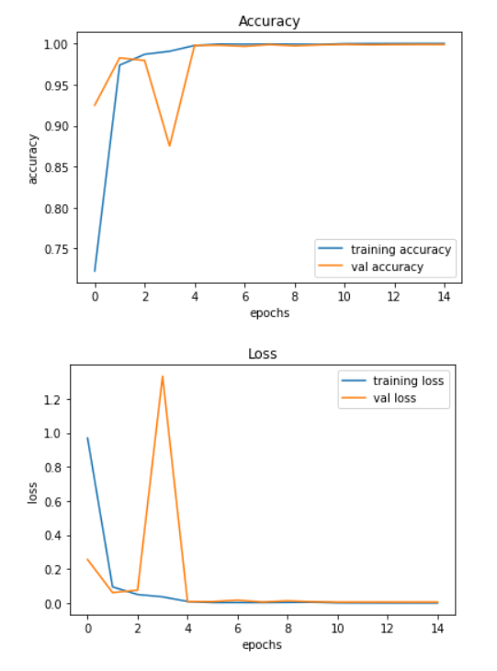

**Model 2: Using CNN**

I used the following architecture to build my second model

model = Sequential()

model.add(Conv2D(filters=32, kernel_size=(5,5), activation='relu', input_shape=(d, d, 3)))

model.add(Conv2D(filters=32, kernel_size=(5,5), activation='relu'))

model.add(MaxPool2D(pool_size=(2, 2)))

model.add(Dropout(rate=0.25, seed=42))

model.add(Conv2D(filters=64, kernel_size=(3, 3), activation='relu'))

model.add(Conv2D(filters=64, kernel_size=(3, 3), activation='relu'))

model.add(MaxPool2D(pool_size=(2, 2)))

model.add(Dropout(rate=0.25, seed=42))

model.add(Flatten())

model.add(Dense(256, activation='relu'))

model.add(Dropout(rate=0.5, seed=42))

model.add(Dense(43, activation='softmax'))

model.compile(

loss='categorical_crossentropy',

optimizer='adam',

metrics=['accuracy'],

)

monitoring2 = 'loss'

filepath="bestCNNModelWeights2.hdf5"

checkpoint = ModelCheckpoint(filepath, monitor=monitoring2, verbose=0, save_best_only=**True**, mode='min')

earlystop = EarlyStopping(monitor = monitoring2, min_delta = 0, patience = 4, verbose = 1,restore_best_weights = **True**)

reduce_lr = ReduceLROnPlateau(monitor=monitoring2, factor=0.2, patience=3, min_lr=0.000001, verbose = 1)

callbacks_list = [checkpoint, earlystop, reduce_lr]

epochs = 40

history = model.fit(datagen_train.flow(X_train, Y_train, batch_size=128), epochs=epochs, verbose=1,

callbacks=callbacks_list, shuffle=**False**, validation_data = datagen_val.flow(X_val, Y_val))

**Model 2 History**

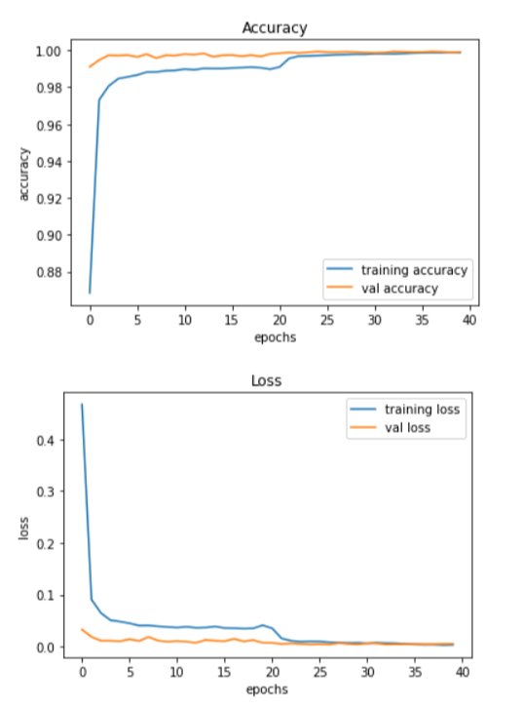

**Model 3: Transfer Learning using VGG19**

I used the following architecture to build my model 3.

**from** **tensorflow.keras.applications** **import** VGG19

base_model_VGG19 = VGG19(include_top = **False**, weights= 'imagenet', input_shape = (d, d, 3), classes = Y_train.shape[1])

model3= Sequential()

model3.add(base_model_VGG19)

*#Adding the Dense layers along with activation and batch normalization*

model3.add(Flatten())

model3.add(Dense(1024, activation='relu'))

model3.add(Dropout(rate=0.75, seed=42))

model3.add(Dense(43, activation='softmax'))

model3.compile(

loss='categorical_crossentropy',

optimizer='adam',

metrics=['accuracy'],

)

monitoring3 = 'loss'

filepath="bestVGG19ModelWeights2.hdf5"

checkpoint = ModelCheckpoint(filepath, monitor=monitoring3, verbose=0, save_best_only=**True**, mode='min')

earlystop = EarlyStopping(monitor = monitoring3, min_delta = 0, patience = 4, verbose = 1,restore_best_weights = **True**)

reduce_lr = ReduceLROnPlateau(monitor=monitoring3, factor=0.2, patience=3, min_lr=0.000001, verbose=1)

callbacks_list = [checkpoint, earlystop, reduce_lr]

history3 = model3.fit(datagen_train.flow(X_train, Y_train, batch_size=256), epochs=epochs, verbose=1, validation_data=datagen_val.flow(X_val, Y_val),

shuffle=**True**, callbacks=callbacks_list)

**Model 3 History**

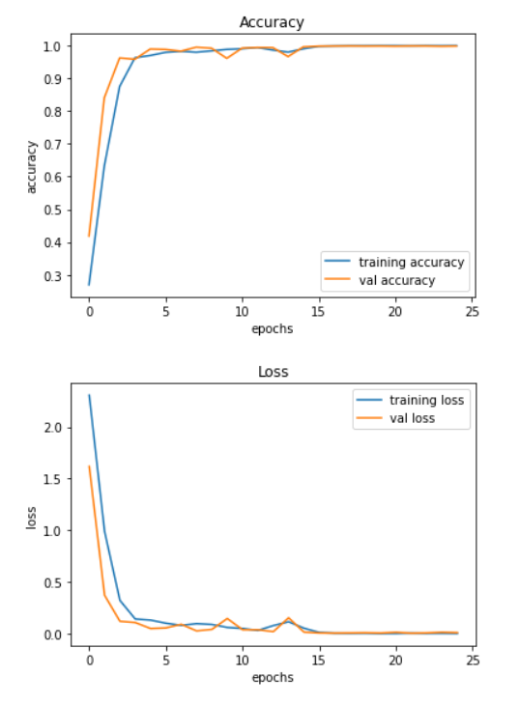

**Testing the accuracies**

The test accuracies of the three models were as follows –

|  |  |
| --- | --- |
| **Model Name** | **Accuracy** |
| CNN Model | 98.72% |
| ResNet50V2 Model | 96.61% |
| VGG19 Model | 98.33% |

* CNN model performed the best
* Confusion Matrix Heat Map for CNN model - 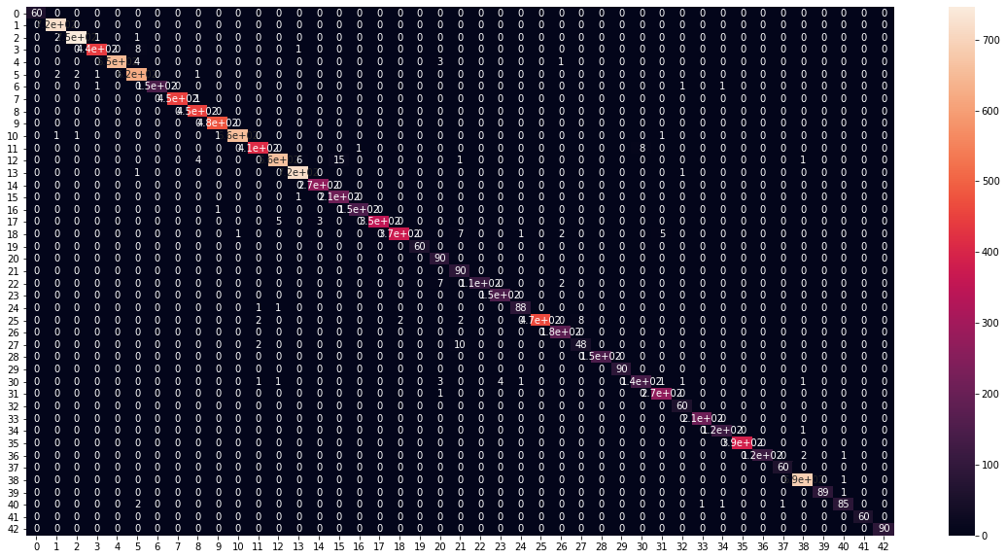

**Ensemble of the Models**

I also create various ensembles of the above models to get more accurate model.

Weighted Ensemble model gave the accuracy of 99.1%

Mean Ensemble (Soft voting) model gave the accuracy of 99.07%

Mode Ensemble (Hard Voting) model gave the accuracy of 98.72%

**Classification report for Mean Ensemble -**

precision recall f1-score support

0 1.00 1.00 1.00 60

1 0.99 1.00 1.00 720

2 1.00 0.99 1.00 750

3 1.00 0.98 0.99 450

4 1.00 0.99 0.99 660

5 0.98 1.00 0.99 630

6 1.00 0.98 0.99 150

7 1.00 1.00 1.00 450

8 0.99 1.00 1.00 450

9 0.99 1.00 0.99 480

10 1.00 1.00 1.00 660

11 0.99 0.99 0.99 420

12 1.00 0.98 0.99 690

13 1.00 1.00 1.00 720

14 0.97 1.00 0.99 270

15 0.93 1.00 0.96 210

16 1.00 0.99 1.00 150

17 1.00 0.97 0.99 360

18 1.00 0.97 0.98 390

19 1.00 1.00 1.00 60

20 0.91 1.00 0.95 90

21 0.83 1.00 0.90 90

22 1.00 0.96 0.98 120

23 0.97 1.00 0.98 150

24 1.00 0.98 0.99 90

25 0.99 0.99 0.99 480

26 0.99 1.00 0.99 180

27 0.93 0.85 0.89 60

28 0.99 1.00 0.99 150

29 0.99 1.00 0.99 90

30 0.98 0.94 0.96 150

31 0.99 1.00 0.99 270

32 0.97 1.00 0.98 60

33 0.99 1.00 1.00 210

34 1.00 1.00 1.00 120

35 1.00 1.00 1.00 390

36 1.00 0.99 1.00 120

37 0.98 1.00 0.99 60

38 1.00 1.00 1.00 690

39 1.00 0.99 0.99 90

40 1.00 0.96 0.98 90

41 1.00 0.95 0.97 60

42 1.00 1.00 1.00 90

accuracy 0.99 12630

macro avg 0.98 0.99 0.99 12630

weighted avg 0.99 0.99 0.99 12630

**Future Improvement Ideas:**

* Do more image augmentations.
* Increase the image input dimension.
* Use more Image generators for better ram management.